صورة تحتوي على رمز, الخط, شعار, الرسومات

تم إنشاء الوصف تلقائياً

**Kingdom of Saudi Arabia**

**Ministry of Education**

**Umm Al-Qura University**

**College of Engineering and Computers**

**(Department of Computer Science)**

**[Blackboard Application]**

**[ 2024 ]**

**Student name:**

**Fatimah Al-Jedaani (444014738)**

**Shahad Ali (444009300)**

**Overview**

With the rapid development of information technology, Learning Management Systems (LMS) have become an essential part of enhancing the educational process. Among these systems, the Blackboard application is one of the most prominent educational tools widely used in universities and educational institutions around the world. This application allows students and faculty members to access educational content, submit assignments, participate in discussions, and manage various aspects of the academic process smoothly and effectively.

In this report, we will review the various types of key features and characteristics of the Blackboard application, and how it contributes to improving the teaching and learning experience, focusing on the benefits it provides to both teachers and students.

**Report Content:**

1. **Chapter 1**
   1. **Introduction……………………………………………………………..4**
   2. **Purpose……………………………………………………………….....4**
   3. **Stakeholders…………………………………………………..………..4**
   4. **Main tasks of Blackboard…………………………………………….4**
   5. **Functional Requirements…………..………………………………...5**
      1. **User requirements………………………………………………..5**
      2. **System requirements……………………………………….……5**
   6. **NON-Functional Requirements…………………………………...…5**
   7. **Conclusion………………………………………………………………5**
2. **Chapter 2**
   1. **The reason for the existence of blackboard ..…………………….7**
   2. **Problems Resolved by Blackboard…………………………………7**
   3. **Questionnaire…………………………………………………….…….8**
   4. **Comparison between Blackboard and Madrasty…………….....10**
   5. **Conclusion………………………………………………………….….12**
3. **Chapter 3**
   1. **Interfaces ……………….……………………………………………..14**
   2. **Data models……………………………………………………………17**
4. **Use case………………………………………………………….17**
5. **Activity diagram………………………………………...……….18**
   1. **Databases………………………………………………………………19**
   2. **Programming language……………………………………………...20**
   3. **Conclusion……………………………………………………………..20**
6. **Final Conclusion………………….…………………….…………..21**
7. **References………….………………….…………………….………21**

**[Chapter 1]**

Blackboard Learn provides an easy way to interact with different types of features, depending on your role, either as an instructor or a student.

* 1. **Introduction:**

Blackboard is one of the modern educational applications in the modern era, as it provides a comprehensive platform for e-learning and manages educational content online. This program is used in many educational institutions around the world, ranging from multi-access educational institutions to higher education institutions.

* 1. **Purpose:**

The primary purpose of Blackboard is to facilitate content management, delivery, and assessment, featuring a variety of educational tools for seamless access to course materials, assignments, discussions, and assessments.

* 1. **Stakeholders:**
* User (Student -Teacher)
* Distance learning team
  1. **Main tasks of Blackboard:**
* Blackboard allows instructors to create and manage courses. This includes organizing and uploading course materials such as syllabi, lecture notes, and multimedia content.
* Blackboard provides a variety of communication tools. This includes discussion boards, messaging systems, and announcements.
* Blackboard supports a range of assessment types, including quizzes, tests, and assignments. also provides automatic grading for certain assessments and provides tools for manual grading and feedback.  
  1. **FUNCTIONAL REQUIRMENTS**
     1. **USER REQUERMENTS:**
* The system must allow the user to log in using the username and password and manage his profile
* The system must support sending notifications and alerts to the user to inform him of status updates
* The user's system must be accessible via multiple devices
* The system must provide the user with the ability to access files and courses
  + 1. **SYSTEM REQUERMENTS:**
* The user shall log in to the system with the user's name and password.
* The system must support sending notifications and alerts to users to inform them of status updates.
* The system must be accessible via multiple devices, ensuring cross-platform compatibility.
* The system must provide users with the ability to access files and courses easily.
  1. **NON-FUNCTIONAL REQUERMENTS**
* The system shall be easy to use and understandable for users regardless of their technological experience
* User data must be well protected and secured
* The system shall be Quick response
* The system shall be available 24 hours
  1. **Conclusion**

In conclusion, the requirements and purpose of Blackboard have been outlined.

The Blackboard application is an essential tool that enhances the effectiveness of

modern education by combining flexibility and ease of use. Its many features make adopting this technology a step towards achieving an integrated and distinguished educational experience.

**[Chapter 2]**

Blackboard is the leading learning management system (LMS), providing a powerful platform for institutions to create, manage, and deliver online courses that foster an interactive and engaging learning experience. This assignment will show you why Blackboard exists, and introduce some of the features and problems it solves.

* 1. **The reason for the existence of blackboard**

Blackboards creation was driven by the need for a more efficient and effective way to deliver education. Traditional classroom settings were often limited by geographical constraints, time constraints, and the availability of resources. Blackboard aimed to address these limitations by providing a flexible and scalable platform for online learning.

* 1. **Problems Resolved by Blackboard**
* Accessibility: Blackboard has made education more

accessible students who live in remote areas or have disabilities

* Flexibility: It offers students the flexibility to learn at their own pace and on their own schedule
* Cost-Effectiveness: By reducing the need for physical classrooms and materials Blackboard can help institutions save costs
* Collaboration: Blackboard fosters collaboration among students and instructors, promoting a more interactive and engaging learning experience
  1. **Questionnaire**

**conducted a survey to collect opinions about the blackboard application:**

<https://form.responsly.com/f/egEOjdNk>

Figure 1 . Shows details to describe the interface used and the speed of this system.

**صورة تحتوي على نص, لقطة شاشة, رقم, الخط

تم إنشاء الوصف تلقائياً**

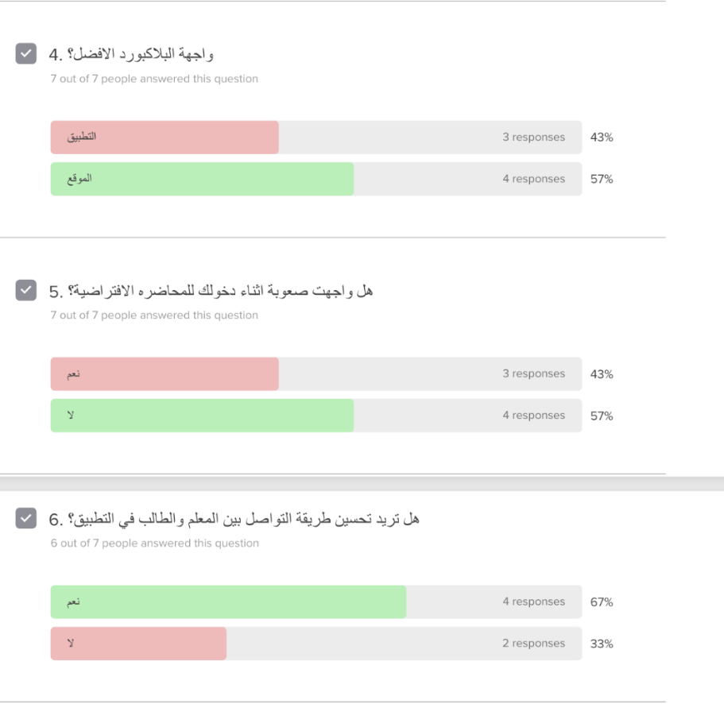

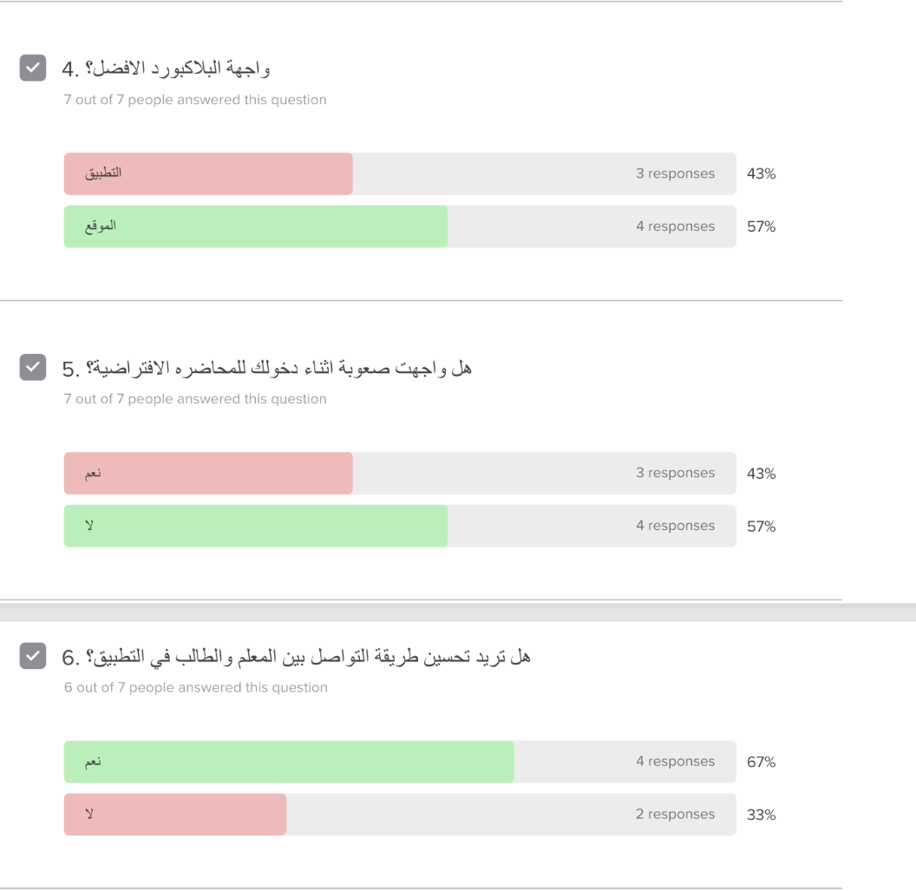Figure 2 . Shows the difficulty level of entering the lecture and communicating with teachers.



Figure 3 . Illustrates the additional features and problems of using Blackboard.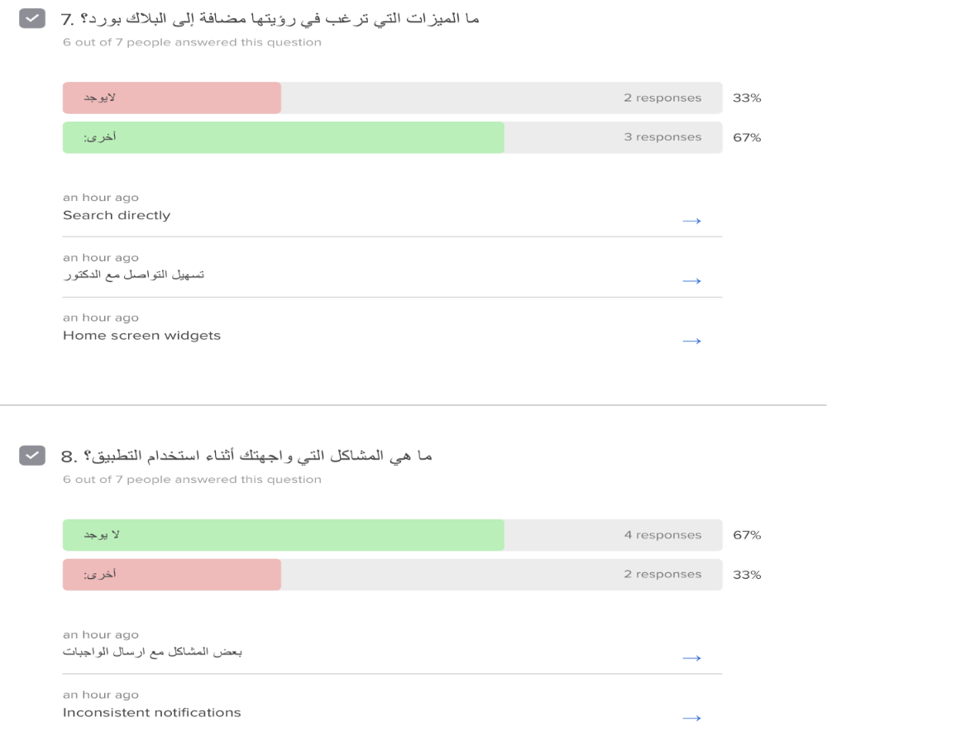

A survey was conducted to gather opinions about Blackboard, as shown in Figure 1. identifying several issues that most students experience, such as difficulty in dealing with the system and technical problems with assignment submissions. which were explored through the survey, shown in Figure 2 and Figure 3. Among the solutions to this problem is making improvements in building the application, which will improve the strength of the application's performance and increase the speed of receiving assignments. Also, the difficulty of communication methods between teachers and students due to the lack of realistic conversations to communicate between them. Therefore, we decided to improve communication by creating a chat interface that allows communication between teachers and students in the application.

* 1. **Comparison between Blackboard and Madrasty**

Blackboard and Madrasty are both popular educational platforms designed to enhance teaching and learning experiences. However, they offer distinct features and cater to different needs. Lets compare their advantages and disadvantages:

**Blackboard**

* + **Advantages:**
* Widely used and established: Blackboard has been a staple in many educational institutions for years, making it a familiar platform for both students and faculty.
* It offers a comprehensive suite of tools, including course management, online testing, discussion forums, and collaboration features.
* Blackboard can integrate with other educational tools and systems, such as learning management systems (LMS) and student information systems (SIS).
* **Disadvantages:**
* The interface can be complex for new users due to its extensive features.
* Like any large-scale platform, Blackboard can encounter technical issues.

**Madrasty**

* **Advantages:**
* Madrasty has a user-friendly interface, designed to be intuitive and easy to navigate, making it accessible to users of all ages.
* The app is optimized for mobile devices, allowing students to access their courses and assignments on the go.
* Madrasty is specifically tailored for Arabic-speaking users, providing features and content relevant to their needs.
* **Disadvantages:**
* It may not offer the same breadth of features like Blackboard.
* Madrasty might have a smaller user community and fewer resources available.

|  |  |  |
| --- | --- | --- |
|  | Blackboard | Madrasty |
| Security | -Both employ security measures to protect user data  -Use secure login and authentication processes  -Regularly update systems to address vulnerabilities  -Comply with relevant data protection regulations | |
| Platform | Web-based, mobile apps, integrates with third-party tools, comprehensive LMS | Primarily mobile app, web version available, focuses on Middle East and North Africa |
| Management | -Both provide centralized systems for managing courses, users, content, and assessments  -Allow administrators to manage user roles and access control  -Offer tools for tracking student progress and performance | |

The following table is a comparison between Blackboard and madrasty in terms of security, platform, and management.

* 1. **Conclusion**

Blackboard effectively enhances the learning experience by enhancing communication between students and teachers and providing easy access to resources. The reasons for Blackboard, the problems it solves, and some of its advantages and disadvantages are explained. A survey was also conducted to identify the problems some people face and suggest ways to improve them. Despite the challenges some users may encounter, the many benefits it offers make it an excellent choice for modern education.

**[Chapter 3]**

This chapter introduces Blackboard design and its importance in improving the user experience. It explores design principles that enhance navigation, access, and engagement, and examines how design choices contribute to creating an interactive learning environment. Additionally, it presents the interfaces, application data models, databases, and programming languages ​​used to develop the Blackboard application.

1. 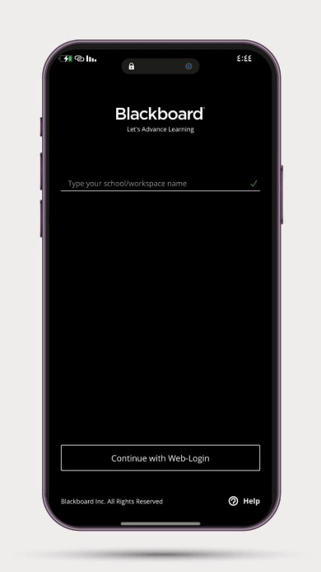صورة تحتوي على الهاتف النقال, أداة ذكية, جهاز اتصالات محمول, جهاز اتصال

   تم إنشاء الوصف تلقائياً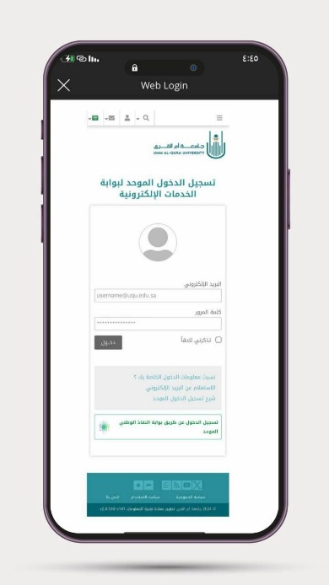**Interfaces**

Figure 6: Login to the university website interface

Figure 5: Login loading interface

Figure 4: Login interface

When you enter the application, the interface shown in Figure 4 appears, which is the Blackboard application login screen. Then, the loading interface appears, as shown in Figure 5, after choosing a specific university, in this case Umm Al-Qura University has been chosen. Then, an interface appears to log in to the university website so that it can be linked to the Blackboard account, as shown in Figure 6. The interface includes entering the email and password, then clicking on the word "Login". The application then verifies the validity of the data to ensure a secure registration.

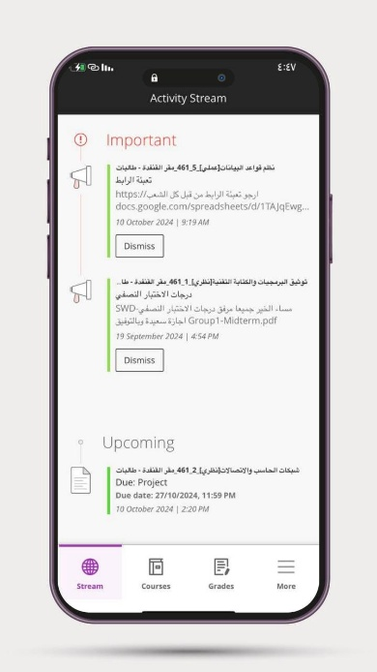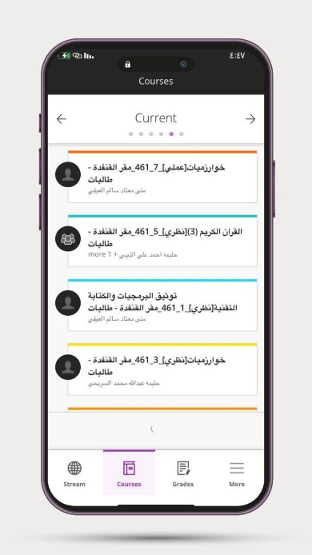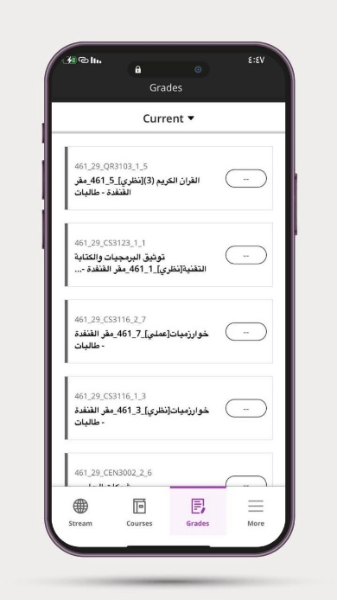

Figure 7: Activity Stream interface

Figure 9: Grades interface

Figure 8: Courses interface

**Activity Stream:** Displays important activities and updates related to courses, with its interface shown in Figure 7. The interface has two main sections:

1. The first section is Important: The "Important" section displays important alerts such as links or information related to courses.
2. The second section is Upcoming: The "Upcoming Assignments" section displays information about future assignments.

**The course interface:** it can be accessed through the Blackboard app, as shown in Figure 8, where different courses are displayed. This design helps students stay engaged and interact easily with their courses.

**Grades interface:** Users can view their course grades, as shown in Figure 9. This interface also allows students to easily track their academic progress and check their grades across different courses.

**صورة تحتوي على نص, لقطة شاشة, برمجيات, صفحة ويب

تم إنشاء الوصف تلقائياً**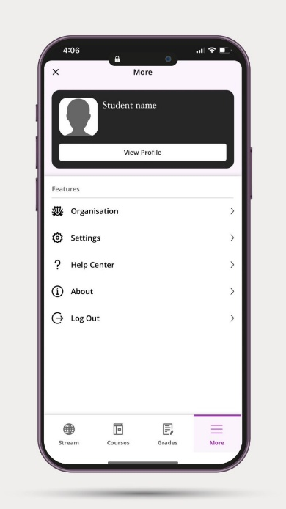

Figure 10: Overview of the More Interface

Figure 11: Umm Al-Qura University website interface

The interface shown in Figure 10 displays the registered student's name, and the More menu includes options for organization, settings, Help Center, About, and sign out.

The interface shown in Figure 11 is the Umm Al-Qura University website. It is designed to facilitate access to the services and information provided to students, employees, and visitors.

1. **Data models**
   * 1. **Use case**

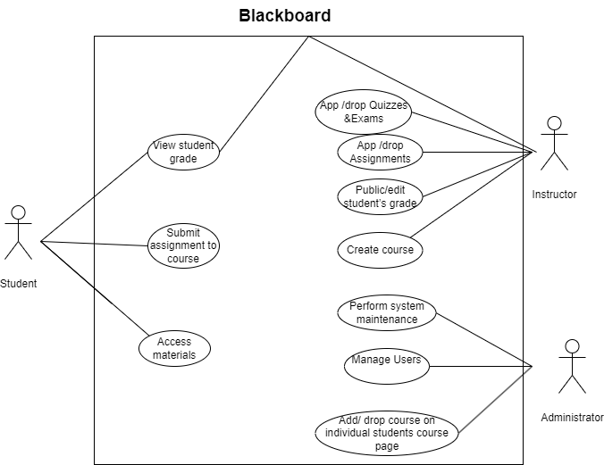

Figure 12: use case

The Blackboard use case model illustrates user roles and actions, as shown in Figure 12 above, which helps system designers and developers gain a better understanding of user requirements.

* + 1. 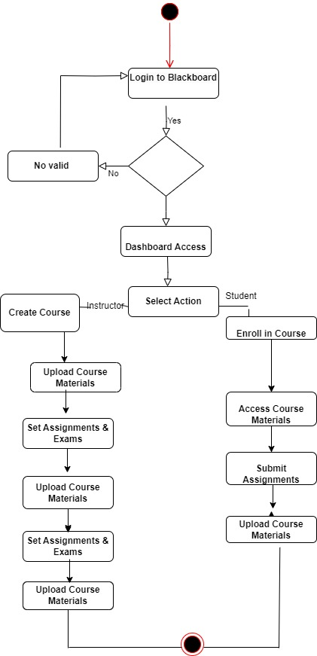 **Activity diagram**

Figure 13: Activity diagram

The activity diagram is used to track and document all activities performed by users within the Blackboard application, whether they are students or professors. This model, shown in Figure 13, helps collect information about users’ interactions with the academic system and includes several main elements.

1. **Databases**

The Blackboard database is a vital element for organizing and managing information on educational activities. It features a structure dependent on various data models, including users, training courses, duties, transmissions and estimates, and are organized in tables. The database stores different types of data, such as user information (name and e-mail), and class details (title and description), and duties (maturity dates, instructions), scores and notes. Relationships between tables are used to connect data, such as linking the user table by the schedule of courses and assigning schedule of submissions.

Database systems often used in the application include:

* Microsoft SQL Server: A popular database in educational systems, providing good performance and scalability.
* MySQL: An open source database used in many educational applications for its flexibility and ease of management.

1. **Programming language**

The blackboard application relies on a variety of programming languages and technologies suited for different tasks:

* JavaScript: It is used in the front-end to interact with users and develop dynamic interfaces. Libraries and frameworks such as React or Angular are also used to improve the user experience.
* PHP: It may be used in some legacy applications or in specific cases such as systems that need compatibility with certain applications or services.
* SQL: It is used to query and interact with databases, whether relational such as MySQL or Oracle.

1. **Conclusion**

In conclusion, this chapter on the design of the Blackboard application plays a crucial role in enhancing user experience and facilitating effective learning. Its intuitive interface and responsive features promote engagement and accessibility for both students and educators. The design addresses various educational needs, ensuring that resources are easily navigable.

1. **Final Conclusion**

Blackboard has emerged as a powerful tool for education, transforming the way knowledge is shared and acquired. By providing a comprehensive suite of features, Blackboard has addressed many of the challenges faced by traditional education systems. As technology continues to evolve, Blackboard is likely to play an even more significant role in shaping the future of education.

1. **References**

* Blackboard Inc. (n.d.). Blackboard. Retrieved from <https://www.blackboard.com/>
* Educational Technology Solutions. (n.d.). Blackboard: A comprehensive guide. Retrieved from <https://www.blackboard.com/>
* University of Michigan. (n.d.). Blackboard help. Retrieved from <https://dataguide.umflint.edu/services/view/13>
* The Chronicle of Higher Education. (2023). Blackboard's new CEO aims to reimagine higher education. Retrieved from <https://www.chronicle.com/>
* Blackboard Help. (n.d.). *Blackboard app feature guide*. Retrieved from<https://help.blackboard.com/ar-sa/Blackboard_App/Feature_Guide>
* Belaraby Apps. (n.d.). منصة مدرستي السعودية. Retrieved from <https://www.belarabyapps.com/>
* Educational Wave. (n.d.). Pros and cons of Blackboard. Retrieved from <https://ar.educationalwave.com/pros-and-cons-of-blackboard/>
* Aspiring Youths. (n.d.). Advantages and disadvantages of Blackboard learning system. Retrieved from <https://aspiringyouths.com/advantages-disadvantages/blackboard-learning-system/>
* For9a. (n.d.). ماذا تعرف عن البلاك بورد. Retrieved from <https://www.for9a.com/learn/>
* Blackboard FAQ. (n.d.). What database does Blackboard use? Retrieved from <https://blackboard-faq.com/what-database-does-blackboard-use>
* Lane, C. A., & Yamashiro, G. (2004). The Blackboard Learning System: The be-all and end-all in educational instruction?. Retrieved from <https://www.researchgate.net/publication/240580066_The_Blackboard_Learning_System_The_Be_All_and_End_All_in_Educational_Instruction>
* Blackboard Inc. (n.d.). Databases in Blackboard Learn. Blackboard Help. Retrieved from <https://help.blackboard.com/ar-sa/Learn/Administrator/Hosting/Databases>
* Accessories: Used Technical Writing Style Guide: Microsoft Writing Style GitHub: <https://github.com/SxSAHAHD>